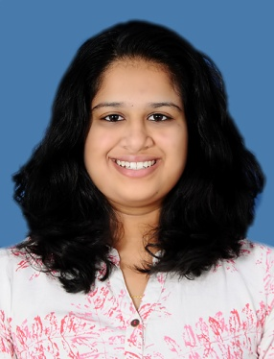

Bhoomika Bharadwaj H B

#335 6TH main
T K Layout, Mysore Pin code: 570009
Phone no: 7353235812
Email : bhoomikabharadwaj89@gmail.com

Career Objective:
To utilize my skills and abilities to the best possible extent to set an example of high standards of performance as a part of technical team.

Academic Qualifications :

Degree | Name of the Institute | University/ Board | Year of Passing | Percentage/ CGPA
B.E.*  (Electronics & instrumentation) | GSSS Institute of Engineering and Technology for Women, Mysuru | VTU,  Belagavi | 2021* | 8.397*
PUC | Vijaya Vittala composite PU college Mysuru | State Board | 2017 | 79%
10th Grade | Vijaya Vittala Vidya Shala, Mysuru | State Board | 2015 | 88.16%

Technical Skills:
Languages: C, C++
Software: MS Office

Personal Traits:
- Active listener, ability to work in a team
- Willing to learn and adapt to new opportunities and challenges
- Strong interpersonal skills
- Confident , disciplined and determined

Co-Curricular Activities:
- Participated in inter-college Roboteer-2019 competition at GSSSIETW, Mysore
- Attended a workshop on "Biomedical Signal and Image Processing at Ramaiah Institute of Technology, Bangalore
- Member of IEEE Forum
- Completed certificate course in Basics of Process Instrumentation at Government Tools Room and
Training center

Intership & Projects:

Internship
Title : Signals and Image Processing and its Application
Company Name: GSSS Institute of Engineering and Technology for Women, Mysuru

Project
Title : Smart Parking Management System Environment: It is being done in a group of three members.
Duration : 1st December 2020 – Present (Proposal and Literature survey completed)

Personal Details:
  - Date of Birth: 14th November 1999
  - Father’s Name: M N Balasubramanya
  - Mother’s Name: S V Savitha
  - Current Address: #335 6th main, 11th cross, T K Layout, Mysuru- 570009
  - Permanent Address: #335 6th main, 11th cross, T K Layout, Mysuru- 570009
  - Hobbies: Reading, Listening Music, Playing Veena, cooking & Badminton
  - Nationality: Indian
  - Languages Known : English, Hindi, Kannada

Declaration:
I hereby declare that all the above mentioned information is true and correct to the best of my knowledge

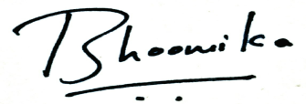
Place : Mysuru E- Signature:

